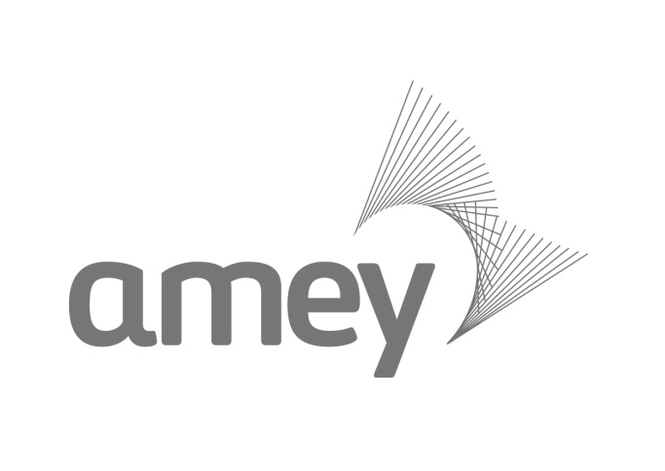

Amey Streets Ahead Community Partnership Programme
Application Form

Amey Streets Ahead Community Partnership Programme
We are commited to supporting local communities close to our operational sites and are pleased to enclose an application form for the 2014/15 Amey Community Partnership Programme.
Five successful groups from across the city have the chance to apply for up to £1,000 towards projects aimed at benefitting the local environment, promoting good relationships between residents and businesses or which help people feel safer in public places.
The fund is open to registered Sheffield based charities and community groups which can demonstrate how the donation will support positive community activities or provide a long-term benefit to the wider community.
Applications must demonstrate how they will provide positive benefit in at least one of the following areas:-
- Improving the local environment and street scene
An example could be transformation of recreational sites for community use. This could include development of adventure playgrounds/community gardens
- Promoting positive relationships between local businesses and residents
An example could be developing initiatives that promote community cohesion between local businesses and local residents to improve the local area
- Enabling people to feel safer in public places
An example could be the purchase of equipment or materials to help with strategies that aim to reduce crime in an area
Guidelines
Donations will be based on activities that directly impact on Amey customers and employees in Sheffield.

Amey will fund:
- Organisations that in some way represent the employees of Amey
- Organisations that represent Amey’s values
- Registered charities and community groups
- Events which seek to directly benefit Sheffield charities or community groups
- Groups must demonstrate the donation will support positive community activities or provide a long-term benefit to the wider community

Amey will not fund, in the context of the Community Partnership:
- Organisations that discriminate on the basis of age, gender, ethnicity or disability
- Individuals
- Organisations or programs designed to influence legislation or elect candidates to public office
- Organisations outside of Sheffield
- Organisations not registered as a charity or "not-for-profit" entity
- Applications in excess of the value of £1000

All requests for donations must be submitted on the Amey Streets Ahead Community Partnership Application form.

Application process
There are two stages to the application process:
- Application Form
Complete the attached Application Form. You will need to give a brief description of the aims of the charity or organisation making the application. You will also need to provide a description of how you will spend the cash grant and give any background information on the project/activity for which you are requesting support.

- Interview
A number of applications will be short-listed for an informal interview. This isn’t as scary as it sounds and will involve a visit from one of our community partnership workers. This will give you an opportunity to tell us more about the project that you propose and help us to ensure that the grants we award are used for the most suitable projects.
In total there will be five grants of £1000 each awarded in 2014.
Please note: Successful applicants must be willing to take part in future promotional activity. This will include particiaption in photo calls and contributing information for press releases, both when the awards are announced and when your projects reach completion.
All decisions will be made by Amey Streets Ahead at its sole discretion. Applicants acknowledge that Amey Streets Ahead has no obligation to the applicant howsoever arising, following submission of the application. Should Amey Streets Ahead decide, at its sole discretion, to award sums to an applicant, the applicant confirms that it will use the money awarded for the purposes stated in the application and will provide evidence of such to the reasonable satisfaction of Amey Streets Ahead within seven days of any such request. Should, in the reasonable opinion of Amey Streets Ahead, the funds not be used by the applicant within the application, the applicant will return the money provided by Amey Streets Ahead within seven days of notification from Amey Streets Ahead,
Closing date
The closing date for applications is Friday 4 July. Shortlisting will take place the week commencing 7 July, with interviews being held the following week.
Amey Streets Ahead Community Partnership Application Form

Any charity, community or voluntary groups requesting a donation from Amey must complete and submit this application form to helen.judge@amey.co.uk

Community group/charity name:
Registered charity number:
Contact name and position in group:
Contact address and postcode:
Postcode where you will use the funding if different from above
Contact email:
Contact telephone:
Date of application

Please give a brief description of the aims of the charity or organisation making this application:
Please give a description of the project that you wish to apply for and show how this meets at least one of the following criteria:-

- Improving the local environment and street scene
- Promoting positive relationships between local businesses and residents
- Enabling people to feel safer in public places.

Please outline how you will spend the cash grant and provide any background information on the project/activity for which you are requesting support:
Are you employed by or does your organisation have links to Amey?
Please provide further detail if applicable.

In completing this application we acknowledge that Amey Streets Ahead will decide, at its sole discretion, to which entity to award donations to. We acknowledge that Amey Streets Ahead have no obligations howsoever arising to the Community group/charity as a result of this application.

CLOSING DATE 5.00 PM, FRIDAY 4 JULY 2014

