Community Assemblies are coming

The countdown is on to the creation of seven Community Assemblies in Sheffield.

The Community Assemblies will, building upon the success of Area Panels, bring Sheffield City Council and the services it delivers closer to people.

Community Assemblies will place local people at the heart of the decision making process so they can directly influence how services are shaped in their areas which meet their local needs. Sheffield currently has 12 Area Panels which have worked with local people, voluntary and community groups for over a decade.

Work is on going and will continue well into the spring to prepare for the arrival of the Community Assemblies. Everyone is invited to get involved and share their views through the Community Assemblies – one of the ways they will do this is by new roadshows in each ward. More details will be announced soon.

Community Assemblies will be developed so they will:

- Give people more opportunities and direct say in influencing services that matter to their community
- Be more flexible and responsive services for their areas
- Help improve neighbourhoods across the city
- Celebrate what has already been achieved, and highlight where performance has improved
- Acknowledge where more needs to be done, and make Community Plans for that area to move forward

The North East Community Assembly will incorporate the wards of Burngreave, Firth Park, Shiregreen and Brightside and Southey and is made up of the 12 locally elected Councillors.
- Burngreave – Cllr Jackie Drayton, Cllr Ibrar Hussain, Cllr Steve Jones
- Firth Park – Cllr Joan Barton, Cllr Alan Law, Cllr Chris Weldon
- Shiregreen and Brightside – Cllr Jane Bird, Cllr Peter Price and Cllr Peter Rippon
- Southey – Cllr Leigh Bramall, Cllr Tony Damms, Cllr Gill Furniss

The South Community Assembly staff team will be –
- Alison Rayner, Community Assembly Manager, who will have overall responsibility for Assembly activities
- Vicky Williams, Planning and Performance Officer, who will help to develop a Community Plan and ensure that services are adapted to local need
- Hannah Isherwood, Assembly Officer, who will ensure good communication and involvement with local residents and groups
- Lisa Moran, Safer Neighbourhood Officer, who works closely with the Police
- And a Team Support Officer, who will provide administrative support to the team.

The Assembly will also be supported by a team of people from other Council services and partner organisations to ensure that residents within the North East Community Assembly receive the best, and most appropriate, services.

Now that the Community Assembly Team has been established there is a lot of work going on in preparation for the launch in May 2009. There will be a variety of neighbourhood events and meetings taking place over the spring and summer that will provide residents with the opportunity to discuss local issues and influence the development of the Assembly’s first Community Plan.

In the meantime if you would like to find out more please contact Alison Rayner on 0114 2037562 or via email – Alison.rayner@sheffield.gov.uk

WEDNESDAY 18th MARCH 2009
from 6pm

VESTRY HALL - BURNGREAVE

This public meeting is about

- Burngreave New Deal – where do we go now? (Ann Allen – BNDfC)
- Area Panel priorities for this year – how have things changed?
- Area Panel spend for this year – where has the money gone, has it been useful?
- …and introducing the North East Community Assembly

Questions invited from members of the public

ALL WELCOME

Sheffield is the home of many people of different backgrounds,

of varying racial and ethnic origins, as well as of different faiths and none.

The City Council wants everyone to be able to play a full part in the life of this city.

We will not accept behaviour at our meetings which is against this principle.

The Area Panel is a committee of Sheffield City Council
We are working to improve the quality of people’s lives in the area
To do this we want to work with you to make sure the
services the Council provide meet local needs.

The Panel aims to make its meetings open to everyone.
If you need help to attend, or more information on this meeting
or the work of the Area Panel contact the
Area Action Office on
276 9134
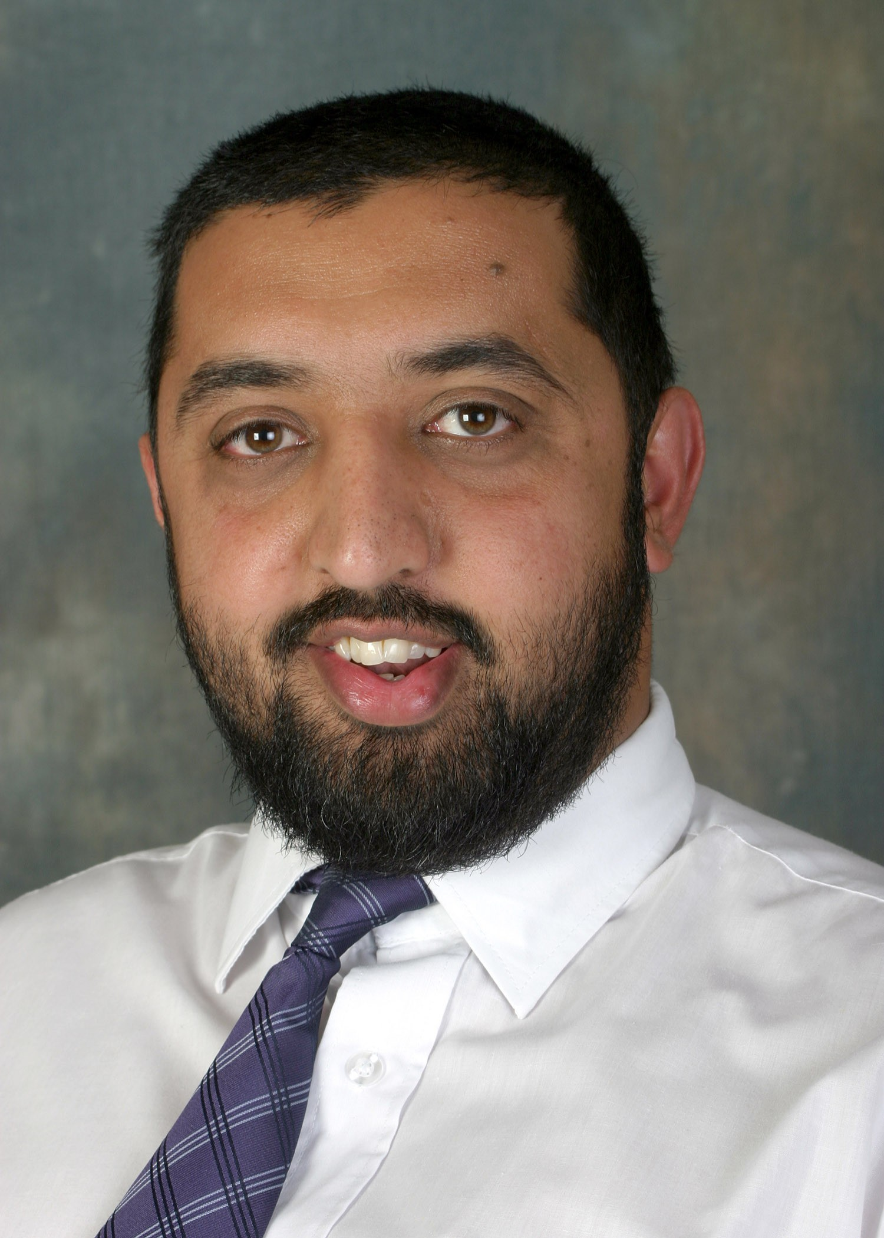
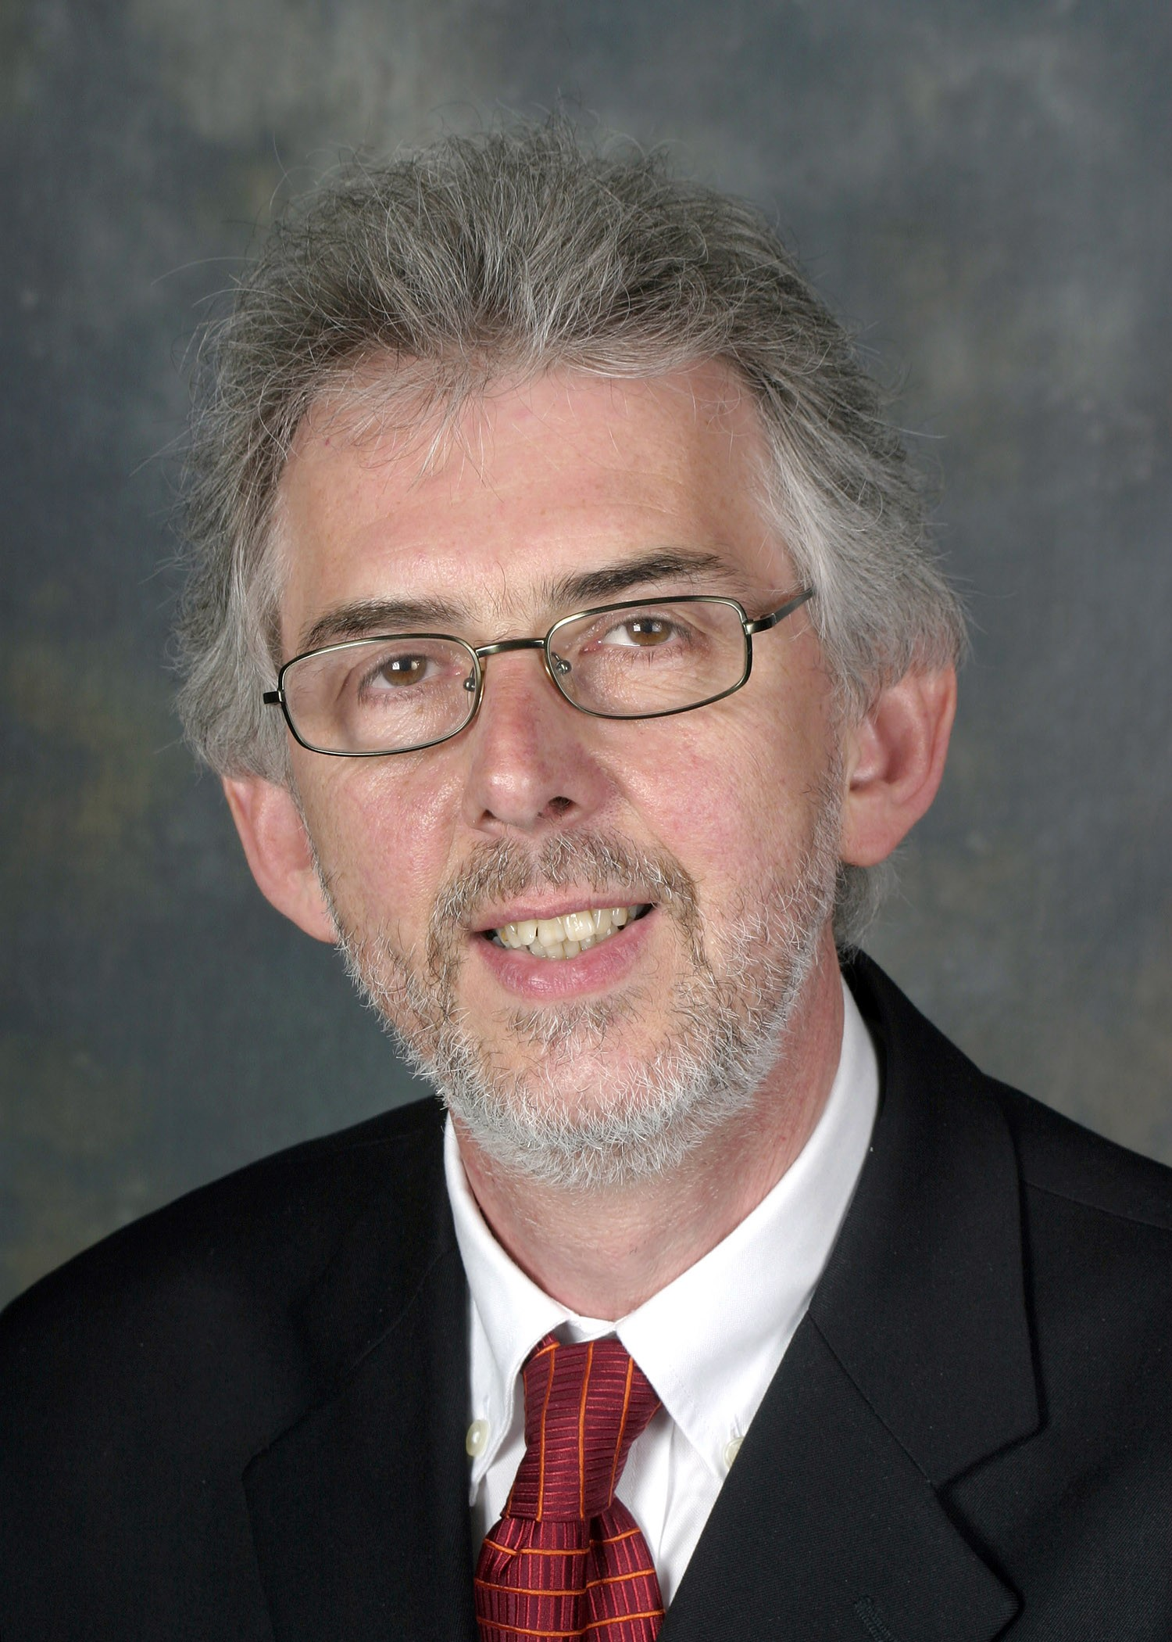
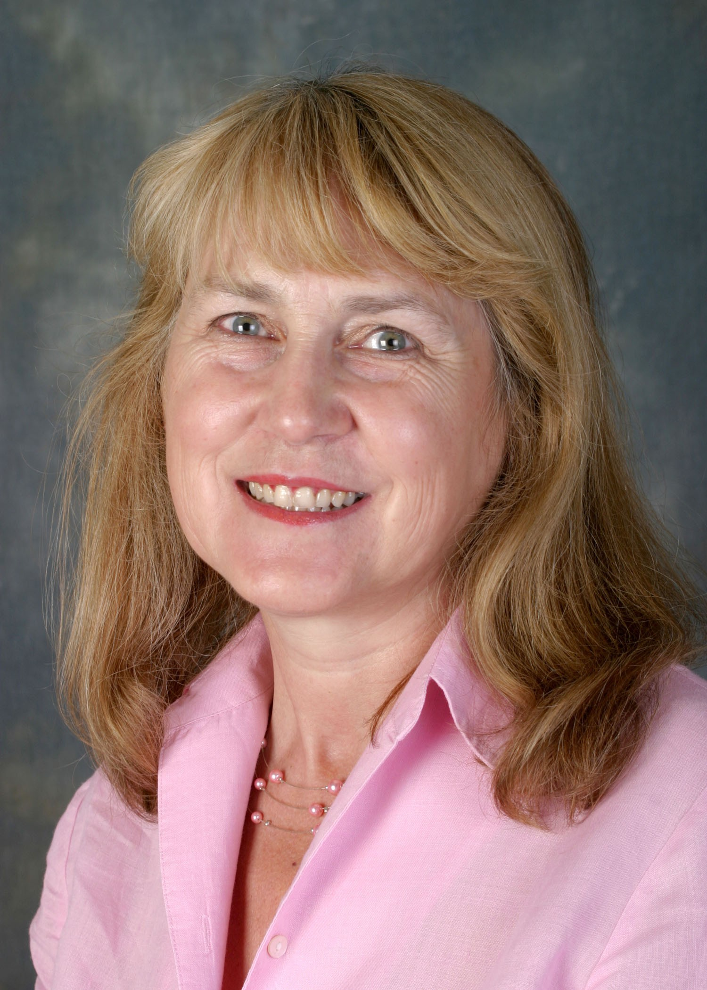
Cllr I Hussain
Cllr S Jones
Cllr J Drayton

